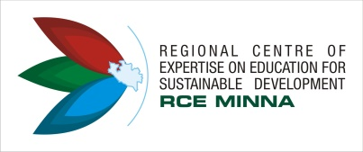
2ND AFRICAN RCE YOUTH VIRTUAL CONFERENCE
Organised by RCE Minna, Nigeria in Collaboration with RCE Grand Rapids, Michigan USA
13th September, 2017
THEME: The Role of Youths in Achieving Good Governance, Leadership and Sustainable Development on the Continent
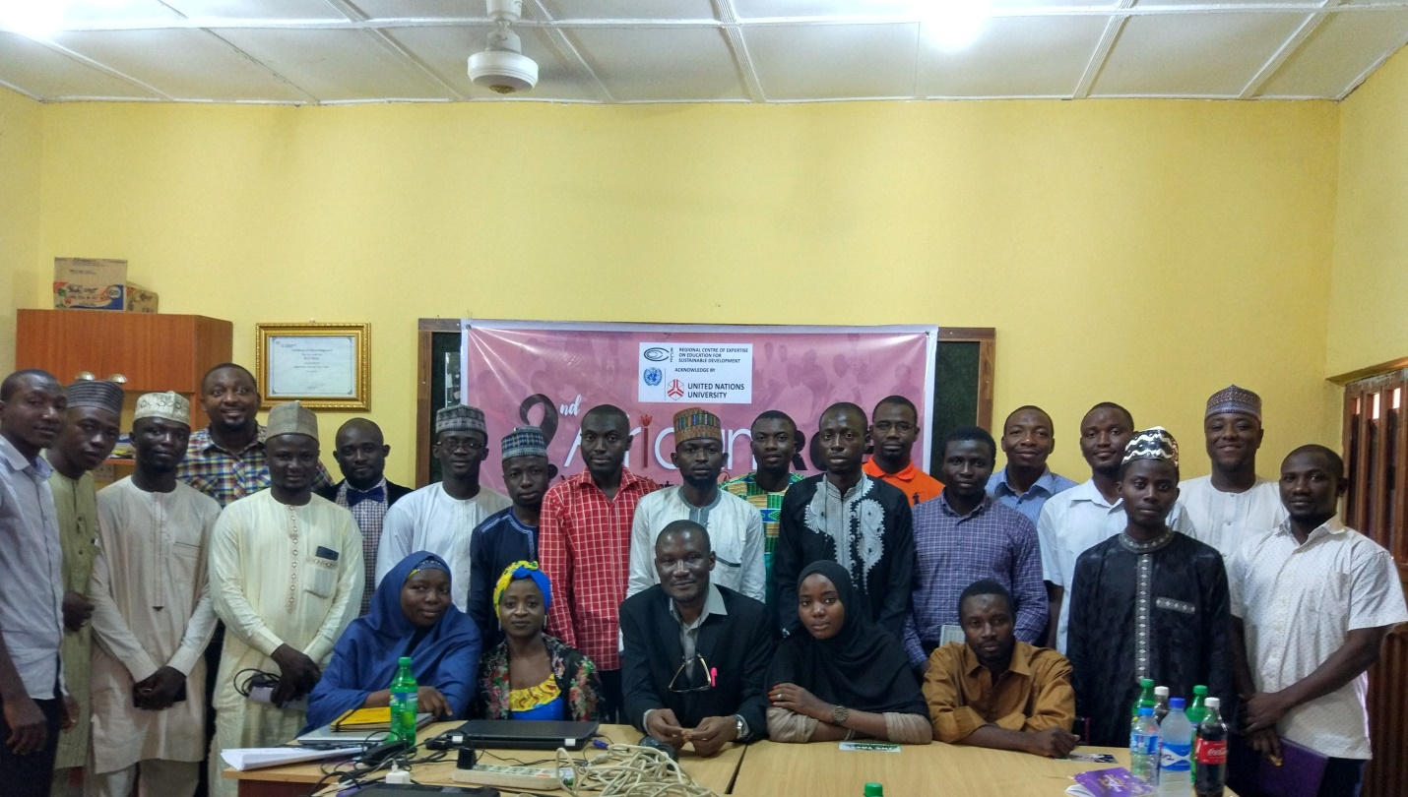
The Regional Centre of Expertise (RCE) Minna in Collaboration with RCE Grand Rapides Michigan, USA organized the 2nd African RCE Youth Virtual Conference with the theme: The Role of Youths in Achieving Good Governance, Leadership and Sustainable Development on the Continent. The Programme was aimed at bringing together youth from across Africa to find a common ground towards taking active role and creating positive impact in their communities without waiting for government support.
In his remarks, the Coordinator of RCE Minna and President of African RCEs, Dr. Abdul Husaini charged the youth to be more proactive in their endeavors. He sighted example of successful young people across Africa and the world at large. He called the attention of the youth to the Sustainable Development Goals and how Africa is to benefit from it.
Also, Mal. Nuru Lemu, the Co-Founder and Pioneer Member of RCE Minna who gave the Keynote address stated that Africa is actually facing numerous challenges from poverty, insecurity, hunger, poor waste management, climate change, governance etc. He however called on the youth to know that nobody will solve the problem of Africa but African themselves. He further advice the youths to utilized their youthful age in making the desired impact in their various communities through the use of modern technology among other means.
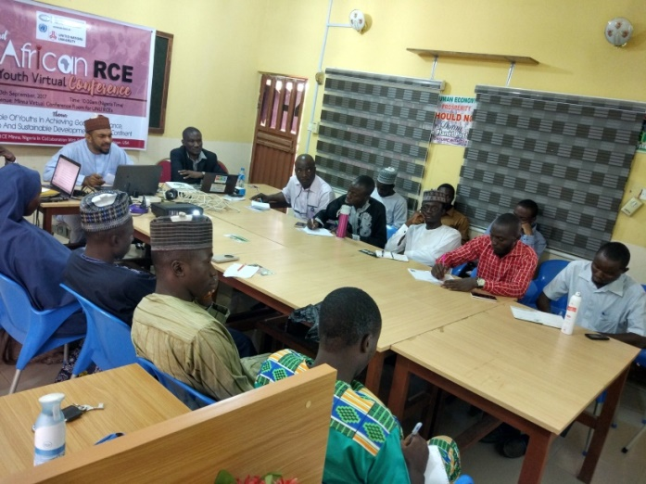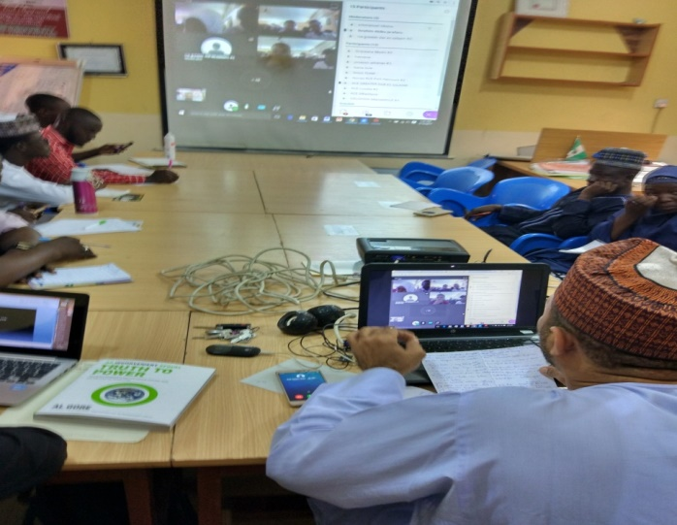

Thereafter, four RCEs, namely, RCE Minna, RCE Swaziland, RCE Lusaka and RCE Zomba made their presentations on youth and good governance according to their various countries. There were series of comments, questions and answer at the end of the presentations.
Major outcomes at the events centred on the fact that all participants agreed that Africa is faced with numerous challenges and the youth need to take active role in finding solutions at our local communities. Also, the conference concludes that youth formed the majority of Africa’s population hence the need for them to come up with smart ideas to move the continent to its desired destination. The need for lifelong learning was also a major outcome at the event; youths were advice to be intellectuals and creative in their endeavors.
Generally, 8 RCEs from Zambia, Malawi, Tanzania, Kenya, Swaziland, Uganda, Cameroon and Nigeria participated at the event. However, there were 35 participants who joined from RCE Minna. Other people from Zaria, Abuja, Jigawa, Kwara and other parts of MInna joined the events too.

