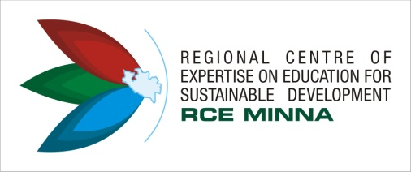
REGIONAL CENTRE OF EXPERTISE (RCE) MINNA
2ND GRADUATE INTERACTIVE SESSION (GIS)
IN COMMEMORATION OF NIGERIA’S INDEPENDENCE AND WORLD HABITAT DAY
1ST OCTOBER, 2018
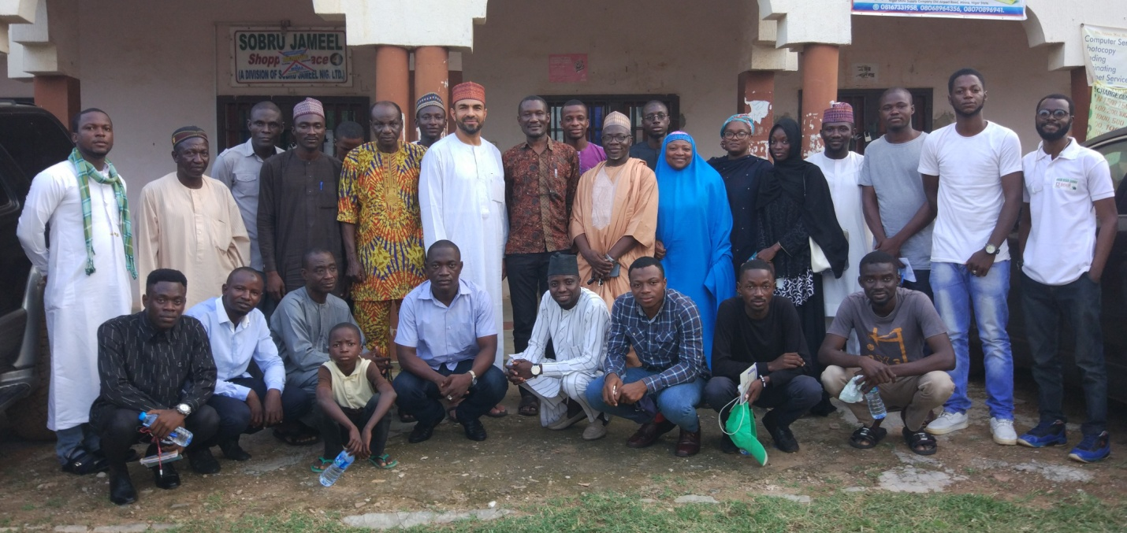
Photo: Group Photograph of GIS 2018 Photo Credit: RCE Minna

Introduction
In 2017 the Regional Centre of Expertise (RCE) Minna organized an interactive session for graduate students of Federal University of Technology (FUT), Minna. The session brought together seasoned lecturers and entrepreneurs from around Minna to share their experiences and prepare the mind of the young graduate towards towing the path of development.
However, in view of the success recorded at the 2017 edition of GIS, there were calls from other students for the second edition. Therefore, to commemorate the Nigeria’s Independence Day and World Habitat Day RCE Minna answered the yearnings of the students and organized the 2nd GIS.
The session had in attendance the Coordinator of RCE Minna- Dr. Abdul Husaini, Chairman RCE Minna board of Research- Prof. GN Nsofor, Mallam Nuruddeen Lemu- RCE Minna, Hajiya Habiba L. Ahmed- DG Urban Board, Mallma Baba Ladan- Coordiantor National Youth Service Corps (NYSC) Kano State and Dr. Francis Gana- RCE Minna. Others include the media, RCE Minna Youth members and the Graduate Students of FUT, Minna.
During the session, presentations were made on an Overview of RCE Minna and its activities, Time Management, Financial Literacy, Life after Graduation and the NYSC experience. The students were charged to focus on their passion and not to be afraid to make mistakes.
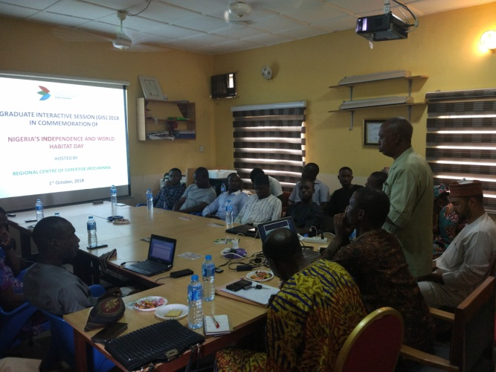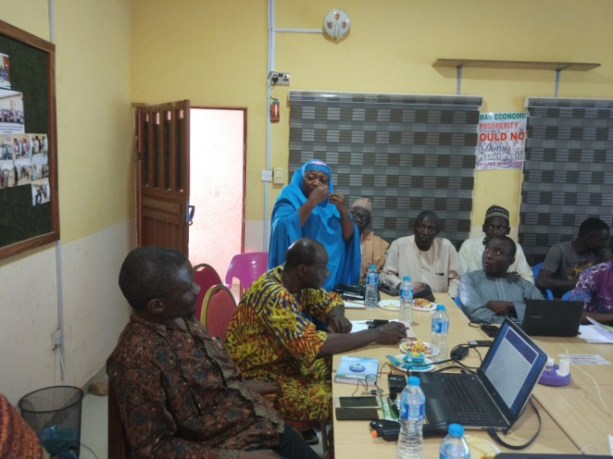
Photo: Presentations at the GIS Photo Credit: RCE Minna
After the presentations, the students were given opportunity to ask questions and make contributions. There questions and enquiries majorly centered on choice of carrier path and personal development.
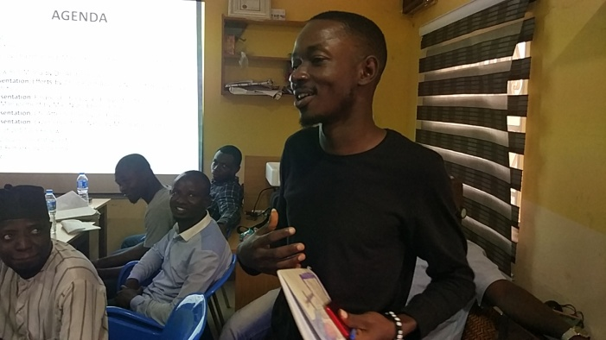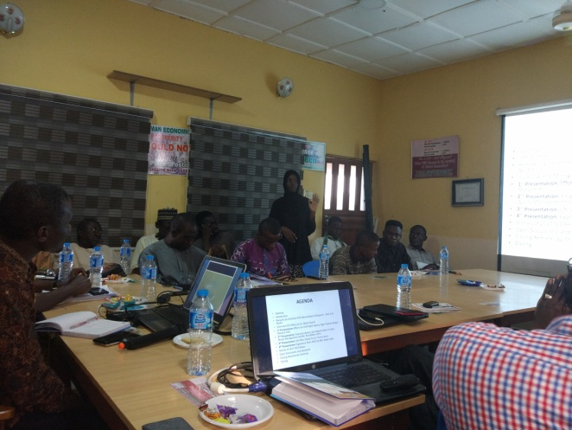
Photo: Students asking questions and making comments Photo Credit: RCE Minna
Furthermore, previous fellows of the GIS sent in their messages through short video clips stating the impact of the 2017 GIS on their activites.
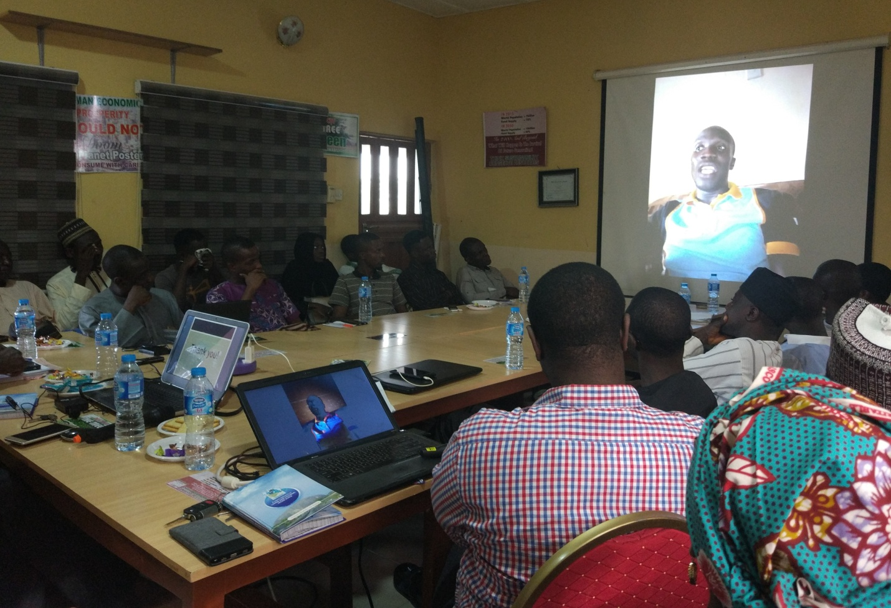
Photo: One of 2017 GIS fellow speaking through video clip Photo Credit: RCE Minna
Major Outcome
The session agreed that:
- The programme should be expanded and allow for more number of students to participate and learn from the interactive session.
- Students should identify mentors and be willing to learn from their experiences.
- The need to cultivate the habit of reading wide and broad is necessary for all in order to enhance the concept of lifelong learning.
Conclusion
The GIS 2018 was an educative and enlightening session that has broadens the mind of young graduates towards taking positive action to help develop their communities. The need to be providing such platforms for young people to interact and share their thoughts is very necessary. RCE Minna will continue to provide learning opportunities for our teeming youth.

