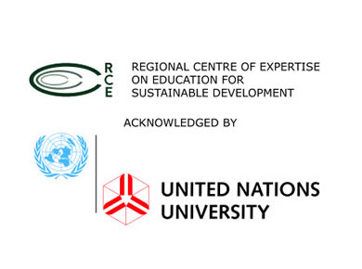
REGIONAL CENTRE OF EXPERTISE (RCE) MINNA
ORGANISED
2016 WORLD ENVIRONMENT DAY (WED) CELEBRATION
GIDAN MATASA, MINNA, NIGERIA
5TH JUNE, 2016
THEME: GO WILD FOR LIFE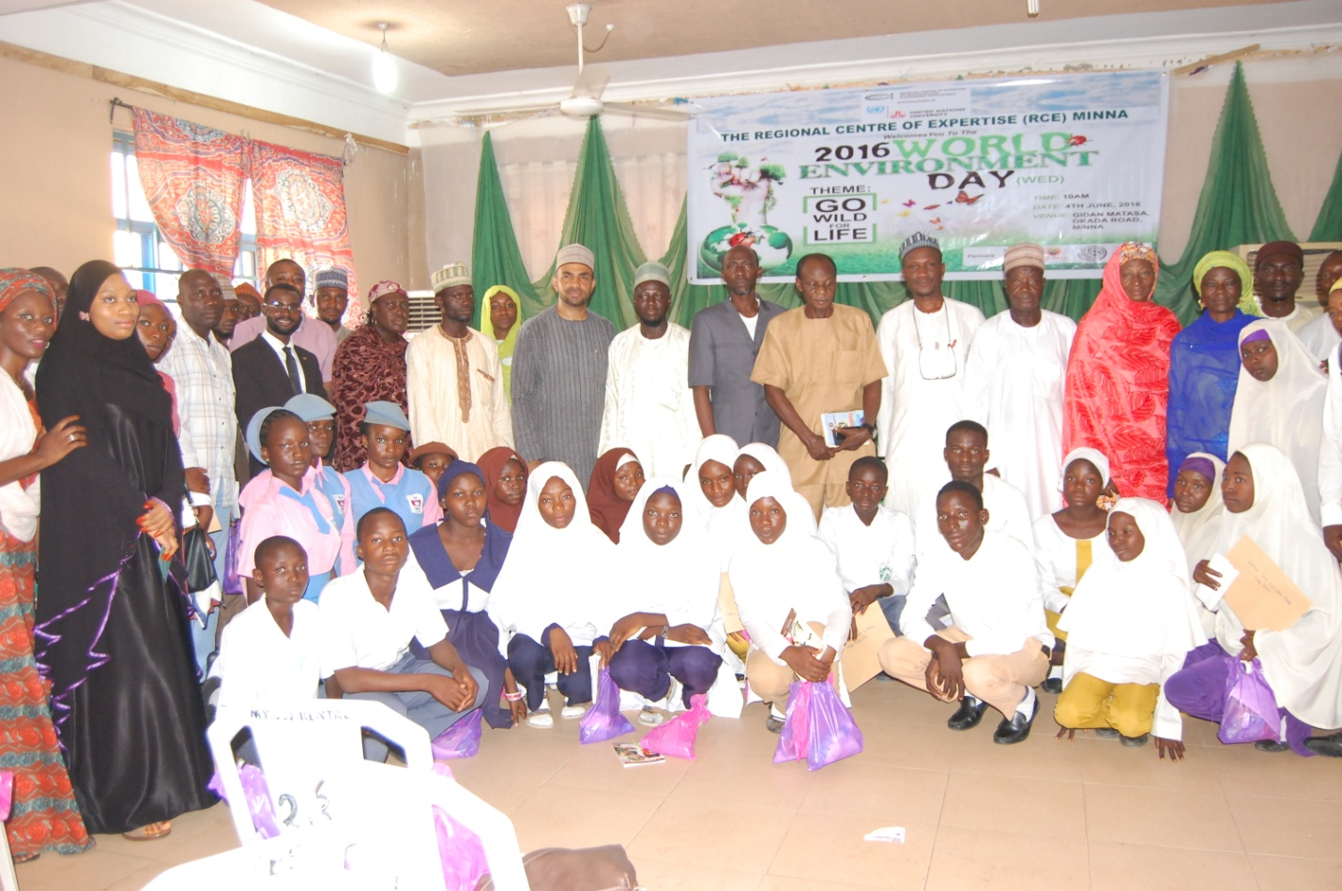
Group Photograph Photo Credit: RCE Minna
For the past five years, RCE Minna has continued to inspire and educate people through the commemoration of the UNEP World Environment Day. It has also created the needed awareness for the activities of the Regional Centre of Expertise (RCE) Minna. This year’s edition of the WED have as its theme: Go Wild for Life. However, RCE Minna and its partners commemorate the day with the screening of a video titled: No Where to Run.
The event had in attendance Profesor G.Nsofor Chairman RCE Minna Board of Research (FUT, Minna), Dr. A. A Okhimamhe Director West African Science Center on Climate Change and Adapted Land Use, FUT Minna (WASCAL), Mal. Baba Wachiko Secretary UNDP Minna Field Office, Hajiya Hauwa Kulu Usman Coordinator Development Partners Support of Niger State Environmental Protection Agency (NISEPA), Mal. Abdullahi Ketso DG NEPAD (Secretary RCE Minna), Representative of Niger State Environmental Protection Agency (NISEPA), Mal. Nuruddeen Lemu-Islamic Education Trust (Research Expert RCE Minna), Arc. Mrs. Hassana Gambo CEO Interflora Landscaping Services/Founder Green Fingers Initiatives, Abuja, Dr. Abdul Husaini GM Niger State Geographic Information System (Coordinator RCE Minna), Lecturers, School Principals, Teachers, University and Secondary School students and the media. Generally, about 200 participants attended the event.
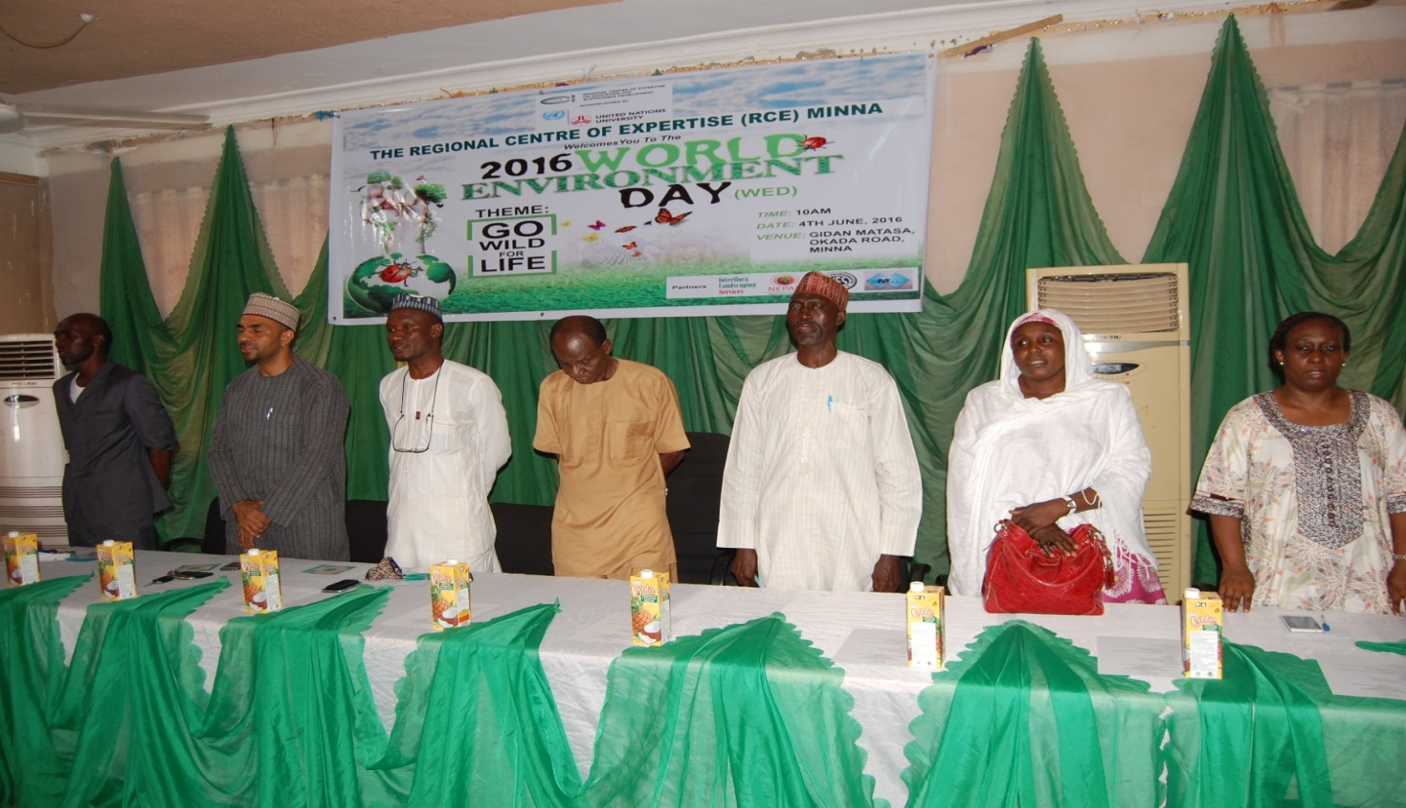
Invited Guest at the Event Photo Credit: RCE Minna
WED 2016
The 2016 WED aims to inspire more people than ever before to take action to prevent the growing strain on planet Earth’s natural systems from reaching breaking point. “The 2016 theme is the fight against the illegal trade in wildlife, which erodes precious biodiversity and threatens the survival of elephants, rhinos and tigers as well as many other species. This year’s slogan “Go Wild for Life” encourages you to spread the world about wildlife crime and the damage it does, and to challenge all those around you to do what they can to prevent it” (UNEP).
NO WHERE TO RUN
The video “No Where to Run” is a documentary on the effects of Climate Change on Nigeria’s Environment Produced by the Yar’adua Foundation in collaboration with the European Union. The video is adjudged by the international community as the most insightful video on the effects of Climate Change on Nigeria’s environment. Therefore, as stakeholders in Sustainable development, RCE Minna organised an awareness campaign to screen the video to the public with the aim of raising the necessary awareness that will possibly change our attitudes towards the environment and at the same time commemorate the WED in grand style as it affects our immediate community.
ACTIVITIES AT THE RCE 2016 WED
This year’s edition of RCE Minna 2016 WED celebration featured several activities that includes;
- Video Screening: The video “No Where to Run” which is the major highlight of the event showcased the effects of climate of change in Nigeria, specifically as it affects the various regions of the nation. Ranging from deforestation, desertification, oil spillage, flooding and erosion. It also went ahead to proffer sustainable and more environmentally friendly solutions to some of the challenges highlighted by the video. Copies of the “No Where to Run Video was distributed to schools and participants.
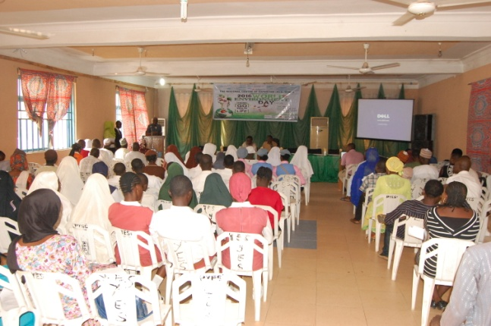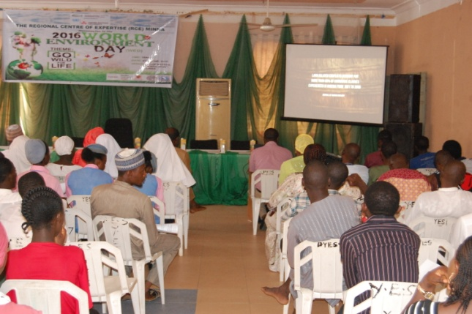
Cross Section of Audience watching the video Photo Credit: RCE Minna
- Breakout Session: Participants at the event were put together for group discussion on the video mentioned above. They were asked to state their understanding of the video, how it relates to their immediate environment, and the possible solutions to those challenges. Participants were grouped based on the different effects of climate change stated in the video (deforestation, desertification, oil spillage, flooding and erosion). There was presentation by various group representatives at the end of the 15 minutes breakout session.
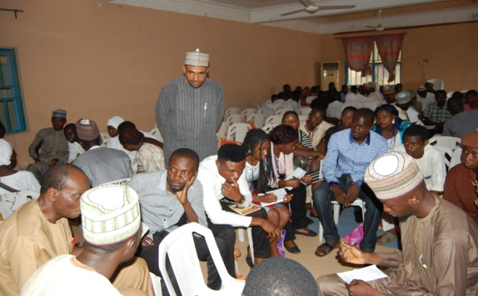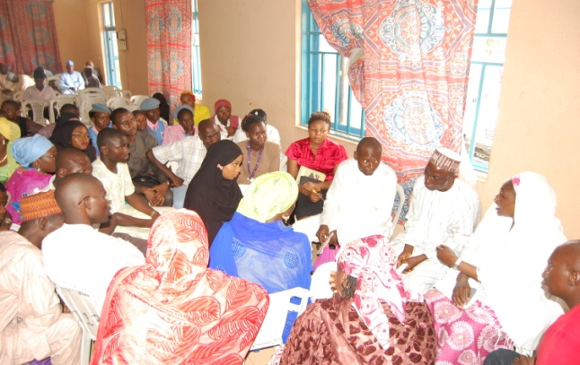
Breakout session Photo Credit: RCE Minna
- Presentation: The event also featured presentation on “Road Map to Sustainable Lifestyle for Nigerians” by Arc. Mrs. Hassana Gambo- CEO Interflora Landscaping Services/Founder Green Fingers Initiatives, Abuja. Her presentation centered on Environmental Sustainability, how climate change and environmental degradation has affected the lifestyle of Nigerians negatively. She went ahead and suggested the need for education and sensitisation as sustainable solutions to the challenges as well as provision of adequate infrastructure (i.e potable water, clean energy, etc). Finally, she advocated the need to also educate the young children on environment. RCE Minna will be organising Holiday Gardening Training for children in Minna later this year.
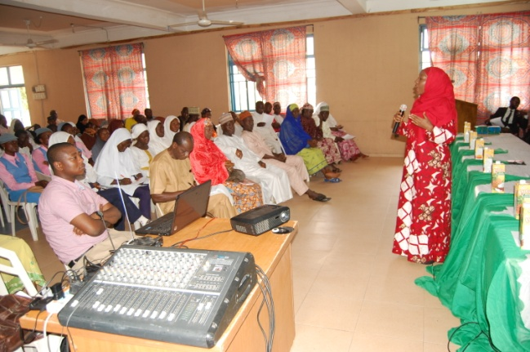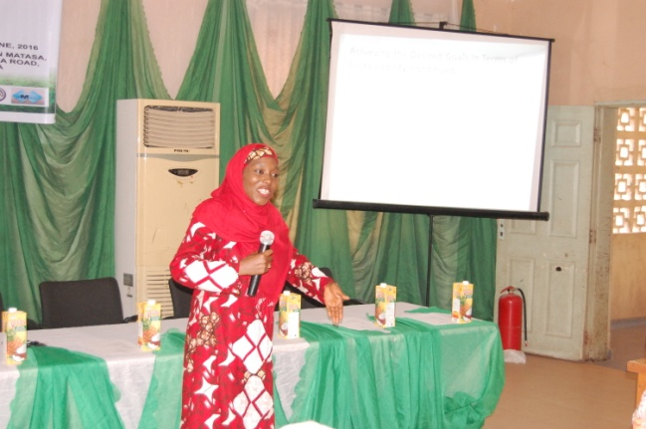
Presentation by Arc. Mrs. Hassana Gambo Photo Credit: RCE Minna
- Launching of RCE Clubs: Another interesting part of the event was the creation of RCE clubs across eleven secondary schools in Minna. The schools majorly public schools, with just two private schools were selected based on their commitments towards environmental sustainability and Education for Sustainable Development. Some of the benefits of been an RCE club includes opportunity for capacity development, leadership training, provision of books on sustainable development, networking and possibility of interacting with other students from within and outside Nigeria through virtual and real conferences among others. Certificates of acknowledgement were given to all the RCE Clubs.
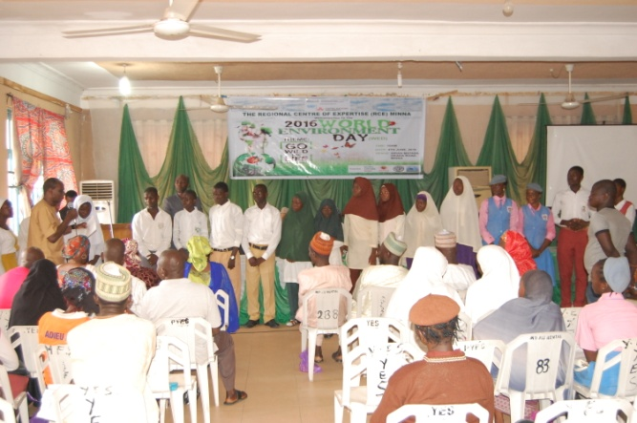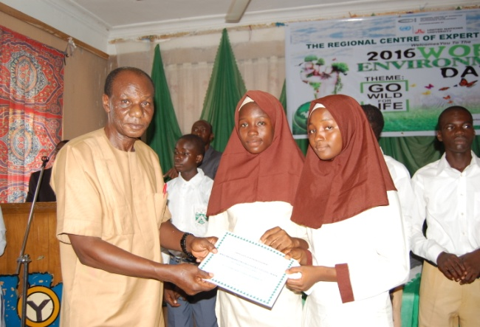
Launching of RCE Clubs Photo Credit: RCE Minna
MAJOR OUTCOMES
- Enhanced commitments and actions for the environment.
- Raised more awareness on climate change in line with goals 11, 12, 13, 14 and 15 of SDGs.
- Promote Education for Sustainable development among children and youth as a priority goal of SDGs (i.e goal 4).
- Promote networking among the students, teachers, lecturers and general public.
- Presentation of awards and incentives to the best performing school from last year’s WED. This is to reflect our continuing efforts to recruit and integrate high school students in creating sustainable social change through rewards for excellence.
- The programme exposed students to take up action individually and collective through the creation of RCE clubs.
CONCLUSION
If there is ever a time for us to collectively join our hands and salvage the earth (our environment) from collapsing, then that time is now. We at RCE Minna will continue to do our best to contribute our quota; however, we have a responsibility as individuals to put in our efforts to create a better living for our children and generation yet unborn. As the Igbo proverbs goes “He who burns down his father’s house, inherit the ashes”.
For more pictures: https://drive.google.com/folderview?id=0BzoJ2Q76LvY_bE9feWEzNmo1Vm8
PARTNERS
Interflora
Landscaping
Services

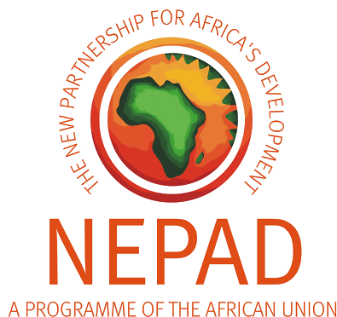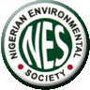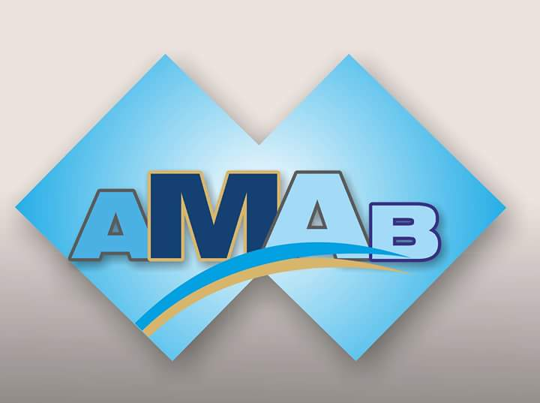
NIGER STATE CHAPTER
RCE MINNA 2016 WED BANNER
